Junit
Maven
Word Document
What is Testing
Agenda
What is Maven?
3) Essential and annotation
4) Test And Cycle
5) Junit Architecture

Unit test -> Unit is small piece of code that call your code and check the answer that what you expect

Analogy: You Make a Cake recipe. But before you see it you take a slice and check how the cake is sweet? its soft? it is cooked ? unit test is similar to that a unit is like a taste check you do in millisecond while running

With test you pressed 1 button and no whether everything works or not JUnit 5 is a library so that gave you to the blueprints to check
Everything follows the same 3 steps
1) Arrange: Set Things up
2) Act: do the thing
3) Assured: check the answer

What is Maven ?
Maven is a project management and build tool primarily used for Java applications. It acts as your automated kitchen manager by handling three core tasks:

1) Download Libraries
2) Compile code for you
3) Run your test in 1 command
Imagine you are a chef (writing Java code) and Maven is your kitchen manager. You simply hand over a shopping list (pom.xml), and the manager handles the rest: they automatically buy the ingredients by downloading required libraries from the internet, set up the kitchen by organizing your folders into standard structures, cook the meal by compiling your raw Java code into bytecode, taste and check the food by running all your unit tests in a single command (mvn test), and finally pack it to go by bundling the finished code into a clean package (JAR/WAR) ready for the customer.

Mvm test : compile everything and runs all its test present in the folder
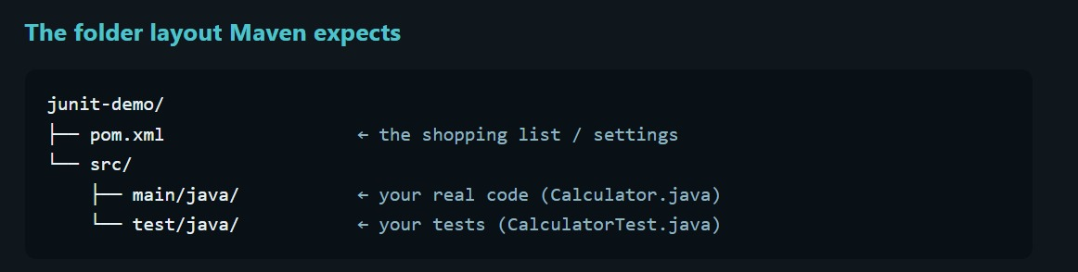
Mvm compile
Mvm source

Mvm clean test : delete the whole target folder first.

Junit Architecture
Steps
1) Design – Understand the problem statement and write down the pseudo code.
2) After algo ready write the code
3) write test
4) Run the Test : using various framework for test

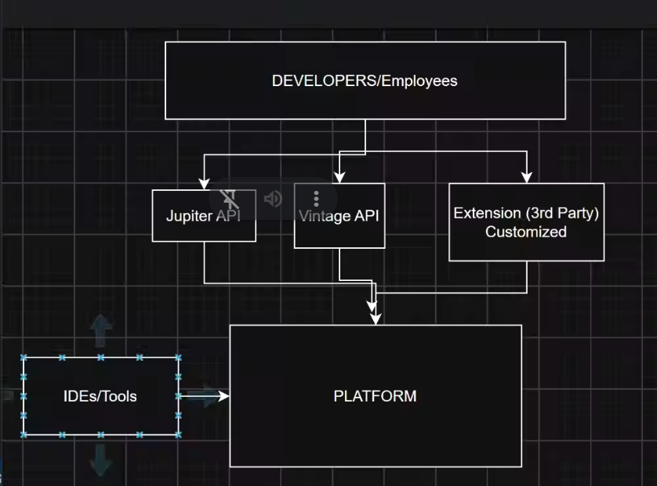
The engine group start test IDEs and intellij meven , define how test engine plugins
Surefire
Junit Jupiter : the junit is used by develoers ,its is new progamming model ; keyword @Test , @BeforeEach , assertions
Also Contains the engine that runs Jupiter test

Junit Vintage Api
The compatibility engine that runs old Junit 3 and 4 test on the new platform its used by old project that haven’t yet migrated

Cinema
Analogy: The platform is a building, projector system and ticket counter its can show you anything it’s can show any movie.
Jupiter is today’s modern movies the only one you can write.
Vintages old movie that run on the same projector. The building doesn’t care what movies plays as long as the matching engine playset.

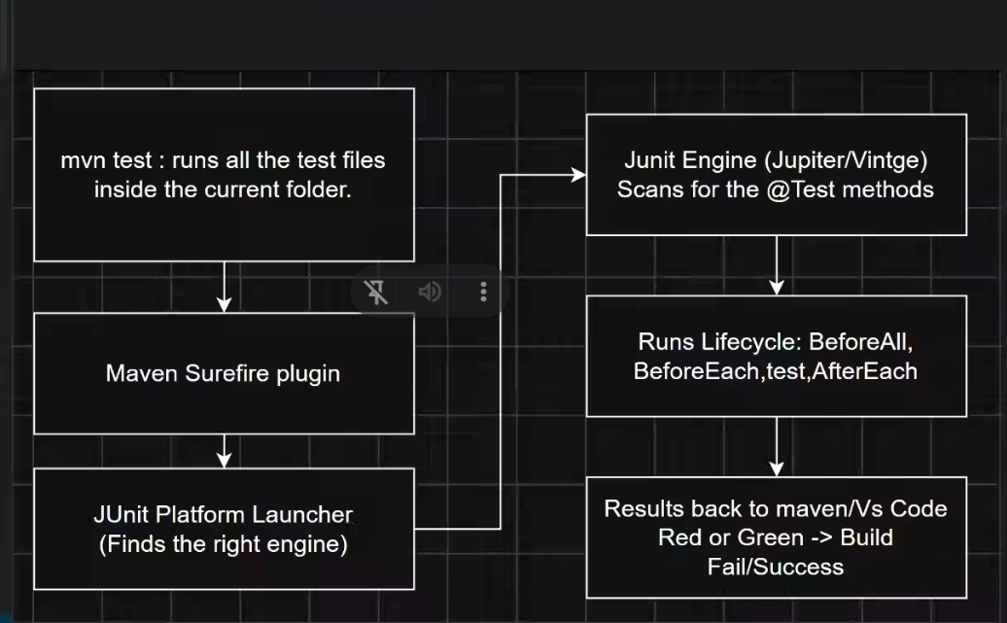

Unit Testing
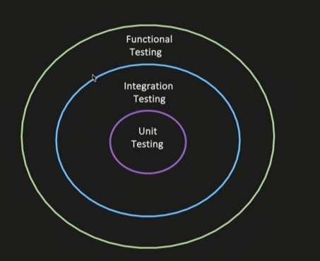

Integration Testing
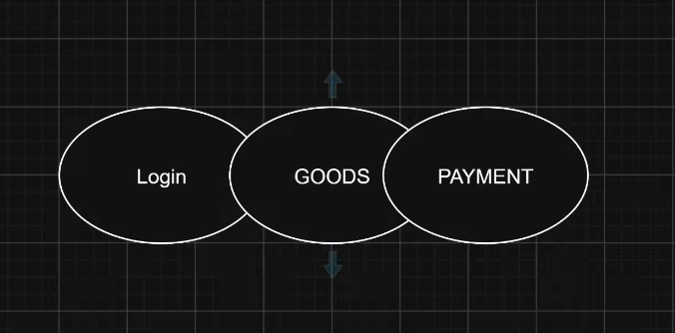
Testing of multiple modules or component together , to test if system works properly when wired together the goal is not to test end to end behaviors, it is just a multiple modules or system wired together does intended behavior.
Use case 1 :
Service -----> Repository -----> DB
1)
2) Verify that dependency injection works correctly
3) The flow should reached that db layer
4) your test can assured that the data was persistent properly in to the DB

Service A ---> Kafka
Validate that the message successfully published in the Kafka module

Functional Testing
End to End Testing of a feature or business functionality, verify it is work as expected

